



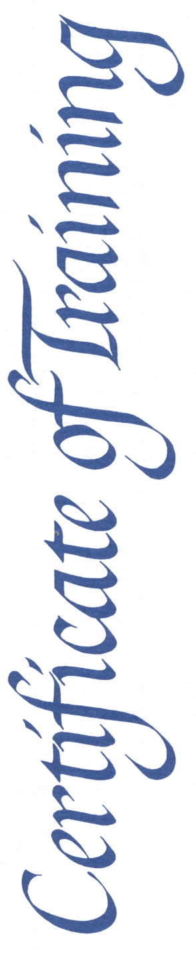

REPLACE THIS TEXT WITH NAME

***SOUTH CAROLINA CADET LEADERSHIP COURSE, CADRE CADET***

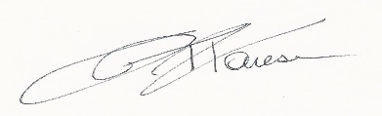

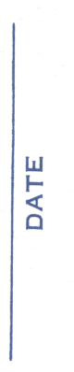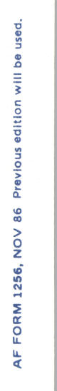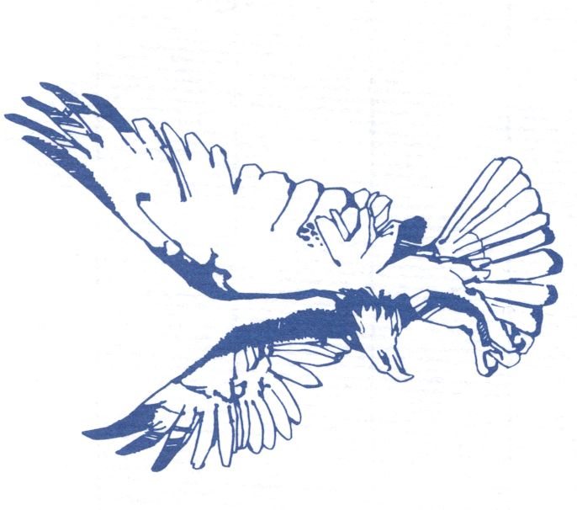

Replace Text with date

MAJ JOHN T. FARESE, USAF (Ret)

Director